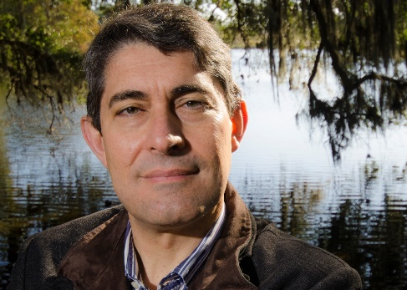

Dr. RAFAEL MUÑOZ-CARPENA
Professor in the Department of Agricultural and Biological Engineering
University of Florida

RAFAEL MUÑOZ-CARPENA, professor, Department of Agricultural and Biological Engineering, University of Florida, Gainesville, Florida, is an educator and researcher focused on hydrological modeling and monitoring of complex integrated environmental systems. Two distinct features of his research and teaching program are the innovative integration of physical, biological, and engineering design principles applied to a wide range of critical issues, such as water pollution, environmental health, and sustainability, along with the internationalization and active professional development and placement of graduate and postdoctoral water engineers and scientists. Muñoz-Carpena actively participates with interdisciplinary expert groups across institutions in the U.S. and worldwide that compete regularly for integrated research program funding from NIFA-USDA, NSF, NASA and the Department of Defense. The model he a developed, the Vegetative Filter Strips Modeling System (VFSMOD), has been accepted as a reference tool for study and design of vegetative filter strips and is used regularly to control runoff pollution by state and federal agencies, and by research institutes in more than 10 countries. He has authored or co-authored more than 400 peer-reviewed journal articles and technical publications, one book, and eleven book chapters, and he is a highly sought after speaker worldwide. In the effort to enrich his research group and foster new collaborations, he regularly hosts international scholars and teaches graduate-level short courses in Europe, Asia and the Americas. He has received various national awards like ASABE John Deer Gold Medal and ADS/Hancor Soil Water national awards, University of Florida educator, faculty, and research excellence awards, and elected fellow of AAAS and ASABE Foreign Member (“Académico”) of the Royal Society of Engineering of Spain.

