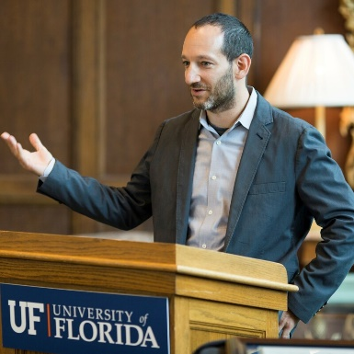

Dr. David Kaplan
Associate Professor in the Department of Environmental Engineering Sciences
University of Florida
Director of the H.T. Odum Center for Wetlands

Dr. David Kaplan is an Associate Professor in the Department of Environmental Engineering Sciences within the Engineering School of Sustainable Infrastructure and Environment at the University of Florida and Director of the H.T. Odum Center for Wetlands. Research in Dr. Kaplan’s Watershed Ecology Lab (www.watershedecology.org) focuses on linkages among the hydrological cycle, ecosystem processes, and human activities, with the goal of advancing natural resources conservation and management. He has worked extensively with water and environmental management agencies to tie hydrological modeling to ecological outcomes, predict restoration effects, and guide water management decision-making.

