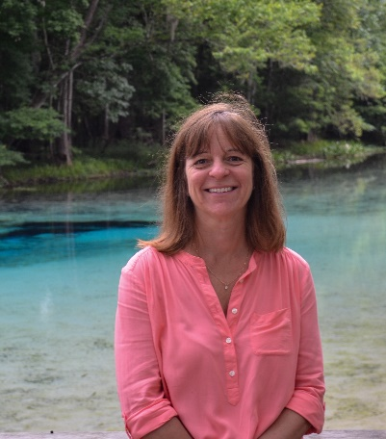

Dr. Wendy D. Graham
Director of the Water Institute at the University of Florida

Wendy D. Graham is the Carl S. Swisher Eminent Scholar in Water Resources in the Department of Agricultural and Biological Engineering and Director of the Water Institute at the University of Florida, Gainesville. Her current research focuses on integrated hydrologic modeling; groundwater resources evaluation and remediation; evaluation of impacts of agricultural production on surface and groundwater quality; evaluation of impacts of climate variability and climate change on hydrologic systems; and stochastic modeling and data assimilation. In her role as Director of the UF Water Institute she coordinates campus-wide interdisciplinary research, education and outreach programs designed to develop and share new knowledge needed to ensure a sustainable water future.

