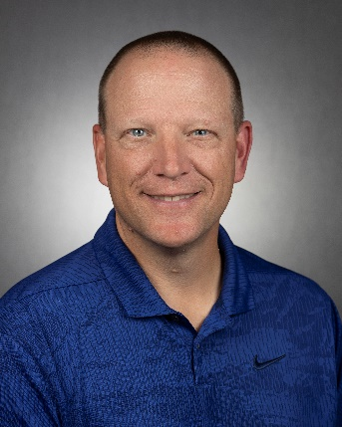
Dr. Michael D. Dukes, P.E., C.I.D.
Director, Center for Land Use Efficiency
Professor of Agricultural and Biological Engineering
University of Florida,
2140 NE Waldo Rd., PO Box 110675, Gainesville, FL 32609
Work Phone: 352-294-6720
E-mail: mddukes@ufl.edu

Michael D. Dukes is the Director of the Center for Land Use Efficiency that combines UF/IFAS urban and agricultural programs associated with best management practices. He is also a Professor and Irrigation Specialist at the University of Florida in the Agricultural and Biological Engineering Department.

Michael obtained a B.A.S. in Agricultural Engineering and an M.C.E. in Civil and Environmental Engineering from the University of Delaware. He obtained a Ph.D. in Biological and Agricultural Engineering from North Carolina State University. His interests are in the area of irrigation and water management, particularly in the area of efficient irrigation design and management, water conservation, and minimizing negative impacts of irrigated systems. Research activities include residential irrigation efficiency, and evaluation of “smart” irrigation control systems such as soil moisture sensor controllers or evapotranspiration based controllers. Extension efforts concentrate on implementation of irrigation control technologies to reduce over-irrigation and loss of nutrients.

He is a Fellow of American Society of Agricultural and Biological Engineers (ASABE) and active in several committees and standards activities. He received the 2011 ASABE Young Extension Worker Award and the 2016 John Deere Gold Medal Award. In 2019 he received both the Heerman Sprinkler Irrigation Award and the Evelyn E. Rosentreter Standards Award. He is Fellow of the American Society of Civil Engineers (ASCE), Environmental and Water Resources Institute (EWRI). He is also a UF Water Institute Faculty Fellow. He has also been active in the Irrigation Association and received the Excellence in Education Award in 2014. He recently received the 2023 Royce J. Tipton Award from ASCE. He is a licensed professional engineer in Florida and a residential Certified Irrigation Designer.

